Class #5

We can create some cron jobs for auto trigger

We can create cron jobs to trigger the Build once any new code commit to Remote Repository.

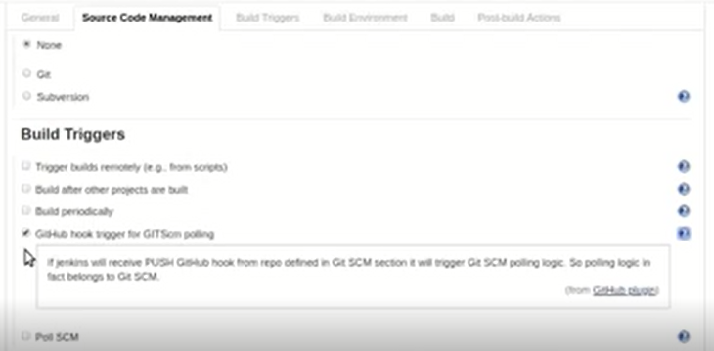

Github hook trigger for GIT

By using this option we can make autotrigger when new code is commited to Remote Repository

For this we need to do some config changes in Jenkins

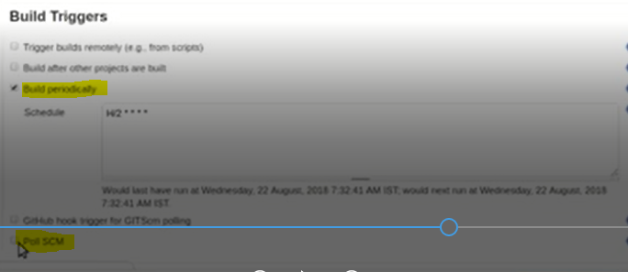

We have two features in Build Triggers

* Build Periodically
* Pool SCM

Build Periodically will Trigger the Job as per the schedule if new code is not available also

Coming to Pool SCM it will trigger the Job only when New code is commited to Remote Repository